Morphometric Study of the Lumbar Intervertebral Disc and Lumbar Spinal Canal in Healthy Egyptians by MRI (from Age 20 up to 60 Year Old)

Abstract
Background: Intervertebral discs are the main articulations of the spinal column, allowing flexibility, bending, and rotation. This study aimed to measure the dimensions of lumbar intervertebral discs (IVDs) and the lumbar spinal canal in Egyptian adults aged 20–60 years, and to assess age- and sex-related variations.
Methods: This retrospective descriptive study included 240 subjects divided into four age groups (20–<30, 30–<40, 40–<50, and 50–<60 years). Each group consisted of 30 males and 30 females. Anterior, middle, and posterior intervertebral disc heights, anteroposterior disc length, transverse diameter, and spinal canal dimensions were measured using imaging studies. Disc degeneration was evaluated using the modified Pfirrmann grading system.
Results: Anterior disc height showed a significant age-related decrease, particularly at lower lumbar levels (L3–S1), while no significant change was observed at L1/L2. Middle and posterior disc heights differed significantly across age groups at most lumbar levels, peaking in middle-aged groups and decreasing in the youngest and oldest groups. Anteroposterior disc length and transverse diameter showed no significant age-related differences. The anteroposterior diameter of the spinal canal at L1 decreased progressively with age, whereas canal width showed modest variation. All disc dimensions were significantly larger in males than females at all lumbar levels (P ≤ 0.001). Disc degeneration increased progressively with advancing age (P < 0.001).
Conclusion: Lumbar intervertebral disc dimensions in healthy Egyptian adults demonstrate clear age- and sex-related variations, with disc heights peaking in middle age, declining in older age, and consistently larger values observed in males.
Keywords Lumbar Intervertebral Disc, Lumbar Spinal Canal, MRI.

Introduction:
The intervertebral discs, situated among the vertebral bodies, serve to connect them, forming the main joints within the spinal column. Forming one-third of the spinal column's height, these discs consistently transmit the loads generated by body weight and muscle movement throughout the spine. Their function includes enabling the spine to bend, flex, and twist, thereby providing flexibility. In the lumbar region, they typically measure around 7 to 10 mm in thickness and 4 cm in diameter ^{[1]}
The intervertebral discs are composed of three primary elements: the interior nucleus pulposus, the outer annulus fibrosus, and the cartilaginous endplates that secure the discs to adjacent vertebrae ^{[2]}.
Degeneration of intervertebral discs occurs much earlier compared to other musculoskeletal tissues. Even as young as 11 years old, signs of disc degeneration can be detected, particularly in the lumbar region. As individuals age, especially males, the degeneration of these discs progressively worsens. By the age of 50, approximately 10% of discs show severe degeneration, increasing to about 60% by the age of 70 ^{[3]}.
Differences in the spinal canal size based on geographic location, race, and gender are present, indicating the need for specific reference ranges for each group. These reference ranges will become standard as quantitative data on spinal canal size becomes readily available through routine MR spine examinations ^{[4]}.
MRI is among the most specific and sensitive imaging modalities for assessing the lumbar spine. Furthermore, there are no adverse impacts associated with radiation. It offers detailed information regarding the vertebral bodies, intervertebral disc spaces, spinal canal, involved the meninges, spinal cord, conus medullaris, cauda equina, and exiting nerve roots ^{[5]}.
The main aim was the measuring of the dimensions of lumbar intervertebral discs (IVD) in Egyptian persons from age 20 up to 60-year-old and measuring of the lumbar spinal canal in the same age groups.

Patients and Methods:
This retrospective descriptive study was performed on 240 cases conducted in Benha University Hospitals and some private radiological centers during the period from October 2024 till May 2025. Patients were allocated based on their ages into four groups; each group included 30 males and 30 females.
Group A: age ranged from 20 years to 30 years.
Group B: age ranged from 30 years to 40 years.
Group C: age ranged from 40 years to 50 years.
Group D: age ranged from 50 years to 60 years.
Approval was obtained from the Research Ethics Committee of the Faculty of Medicine, Benha University (Approval No. MS 44-5-2024). Written informed consent was obtained from all participants prior to inclusion in the study.
Inclusion criteria involved age between 20 and 60 years, Egyptian nationality, cases with no known musculoskeletal, neurological, or systemic disorders affecting the spine with no history of low back pain, sciatica, or spinal discomfort within the preceding 12 months, and no history of lumbar spine trauma or surgery. Exclusion criteria included cases with history of chronic disease affecting lumbar spine; congenital or developmental disease, adverse neurological conditions, neoplastic growth, vertebral and muscular abnormalities, spine surgery, scoliosis or trauma that affected the anatomy of lumbar spine, pregnancy due to potential safety concerns associated with MRI ^{[6]}, any case with non-MRI-compatible metallic implants, pacemakers, or severe claustrophobia, and morbid obesity BMI >40 kg/m² as it is known to influence the structural and functional biomechanics of the spine. Additionally, excessive adipose tissue can degrade image quality due to increased noise, reduced resolution, and motion artifacts ^{[7]}.
All cases were subjected to detailed history taking, general examination, spinal examination (inspection for deformities, palpation for tenderness or abnormalities along the lumbar spine, and assessment of range of motion of the lumbar spine), neurological screening, and MRI examination (obtained by T1 and T2 sequences) to evaluate the lumbar intervertebral disc and spinal canal).
Modified Pfirrmann Grading System:
This study used a grading system for lumbar degenerative disc disease based on sagittal T2-weighted MRI, describing eight grades from normal discs to severe degeneration with loss of disc signal, reduced disc height, and end-plate changes ^{[5]}.
The mid-sagittal section of the discs was used to assessed horizontal and vertical lengths, while the axial section was used for transverse dimensions ^{[8]}.
Measurements included: Anterior Intervertebral Height (AIVH): length between the most anterior points of the upper and lower vertebrae at the disc level. Middle Intervertebral Height (MIVH): distance between the central part of the lower margin of the upper vertebra and the central part of the upper margin of the lower vertebra. Posterior Intervertebral Height (PIVH): distance between the most posterior points of the upper and lower vertebrae. Anterior-Posterior Disc Length (APDL); length between the midpoints of AIVH and PIVH. Transverse Dimension (TD): distance between the most lateral points of the disc on each side. Spinal canal dimensions were measured as follows: Anteroposterior (AP) dimension: from the posterior vertebral margin to the cortex of the neural arch at the spinous process base. Spinal canal width: from the inner margin of one pedicle to the inner margin of the contralateral pedicle ^{[9]}.
Statistical analysis
Statistical analysis was assessed by SPSS v26 (IBM Inc., Armonk, NY, USA). Shapiro-Wilks test and histograms were used to assess the normality of the distribution of data. Quantitative parametric data were presented as mean and standard deviation (SD) and were analyzed by unpaired student t test in comparison among males and females or by ANOVA (F) test with post hoc test (Tukey) in comparison among the four study groups. Qualitative data were presented as frequency and percentage (%) and were analyzed using Chi-square test. A two tailed P value ≤ 0.05 was considered statistically significant.

Results:
The AIVH decreases with age, particularly noticeable at the lower lumbar levels (L3–S1). While the differences at L1/L2 were not statistically significant, L2/L3 and all lower levels (L3–S1) showed significant reductions in older groups (P < 0.05) (Table 1, Figure1). The MIVH varied significantly among age groups at most lumbar levels (L1–L4, L5/S1, P < 0.001) with no significant difference at lumbar level (L4–L5). The highest MIVH values were observed in middle-aged groups (B and C), while younger (A) and older (D) groups tended to have slightly lower values (Table 1, Figure 2). The PIVH showed significant differences among age groups at most lumbar levels (L1–L4, L5/S1, P ≤ 0.01) with no significant difference at lumbar level (L4–L5). Middle-aged groups (B and C) had higher PIVH, while the youngest (A) and oldest (D) groups showed slightly lower values (Table 1, Figure3). The APDL and TD did not differ significantly among age groups at any lumbar level (L1–S1, P > 0.05) (Table 1, Figure 4). The spinal canal anteroposterior dimension at L1 disc was significantly progressively reduced with age progression (P < 0.001). Notably, Group A (younger adults) had the largest anteroposterior dimension while Group D showed the smallest anteroposterior dimension (Table 1, Figure 5). The spinal canal width at the L1 disc level differed significantly among age groups (P = 0.019). Although the differences are small, Group B and C exhibit slightly wider canals than Groups A and D. (Table 1)
Table 1: Comparison of lumbar intervertebral disc and spinal canal dimensions across study population
 | Group A | Group B | Group C |  | Group D |  | P value
AIVH (mm)
L1/L2 | 9.80 ± 1.12 | 10.25 ± 1.05 | 9.82 ± 1.08 |  | 9.15 ± 0.96 |  | 0.061
L2/L3 | 10.45 ± 1.15 | 10.92 ± 1.08 | 10.43 ± 1.07 |  | 9.78 ± 1.01 |  | 0.036*
L3/L4 | 11.12 ± 1.18 | 11.72 ± 1.12 | 11.15 ± 1.09 |  | 10.45 ± 1.05 |  | <0.001*
L4/L5 | 11.65 ± 1.21 | 12.20 ± 1.10 | 11.60 ± 1.11 |  | 10.92 ± 1.06 |  | <0.001*
L5/S1 | 11.78 ± 1.20 | 12.32 ± 1.14 | 11.74 ± 1.13 |  | 11.05 ± 1.08 |  | <0.001*
MIVH (mm)
L1/L2 | 9.91 ± 0.82 | 11.21 ± 1.04 | 10.64 ± 1.06 |  | 9.87 ± 0.65 |  | <0.001*
L2/L3 | 10.91 ± 0.97 | 12.45 ± 1.05 | 11.47 ± 0.85 |  | 10.96 ± 0.75 |  | <0.001*
L3/L4 | 11.92 ± 1.33 | 14.20 ± 1.08 | 13.04 ± 1.07 |  | 12.90 ± 0.88 |  | <0.001*
L4/L5 | 13.45 ± 1.24 | 15.02 ± 1.21 | 14.01 ± 0.93 |  | 13.81 ± 0.86 |  | 0.805
L5/S1 | 12.02 ± 0.86 | 12.86 ± 1.14 | 12.68 ± 0.89 |  | 13.18 ± 0.91 |  | <0.001*
PIVH (mm)
L1/L2 | 7.77 ± 0.81 | 8.38 ± 0.74 | 7.82 ± 0.49 |  | 7.39 ± 0.52 |  | <0.001*
L2/L3 | 8.36 ± 0.72 | 9.28 ± 0.98 | 9.00 ± 0.52 |  | 8.43 ± 0.54 |  | 0.002*
L3/L4 | 9.13 ± 0.67 | 10.44 ± 1.13 | 10.09 ± 0.82 |  | 9.41 ± 0.62 |  | <0.001*
L4/L5 | 10.41 ± 0.81 | 11.67 ± 1.35 | 10.83 ± 0.74 |  | 10.43 ± 0.83 |  | 0.369
L5/S1 | 7.98 ± 0.89 | 8.40 ± 1.06 | 8.55 ± 0.65 |  | 8.26 ± 0.55 |  | 0.010*
APDL (mm)
L1/L2 | 36.18 ± 2.04 | 35.90 ± 2.12 | 36.18 ± 2.02 |  | 35.23 ± 1.94 |  | 0.248
L2/L3 | 37.09 ± 2.03 | 36.56 ± 1.88 | 36.87 ± 2.08 |  | 37.08 ± 2.07 |  | 0.770
L3/L4 | 38.05 ± 2.03 | 38.04 ± 2.05 | 37.83 ± 1.67 |  | 37.78 ± 2.41 |  | 0.976
L4/L5 | 39.52 ± 2.49 | 38.59 ± 2.42 | 38.94 ± 2.32 |  | 38.74 ± 2.07 |  | 0.311
L5/S1 | 38.05 ± 2.42 | 38.11 ± 2.11 | 37.55 ± 2.11 |  | 37.99 ± 2.17 |  | 0.756
TD (mm)
L1/L2 | 53.46 ± 2.81 | 53.42 ± 2.80 | 53.07 ± 3.06 |  | 53.25 ± 2.64 |  | 0.534
L2/L3 | 55.42 ± 3.06 | 55.14 ± 2.62 | 55.53 ± 3.01 |  | 55.30 ± 2.33 |  | 0.603
L3/L4 | 57.64 ± 3.26 | 57.01 ± 3.35 | 57.67 ± 2.91 |  | 57.28 ± 4.01 |  | 0.215
L4/L5 | 59.75 ± 3.22 | 59.26 ± 3.00 | 59.45 ± 3.42 |  | 59.33 ± 3.59 |  | 0.622
L5/S1 | 58.74 ± 2.33 | 58.74 ± 3.58 | 58.32 ± 3.18 |  | 57.90 ± 2.98 |  | 0.201
Spinal canal anteroposterior dimension (mm)
L1 | 18.46 ± 0.89 | 18.21 ± 1.02 | 17.74 ± 1.09 |  | 17.45 ± 0.97 |  | <0.001*
Spinal canal width (mm)
L1 | 21.64 ± 1.13 | 22.23 ± 1.1 |  | 22.07 ± 1.12 |  | 21.75 ± 1.22 |  | 0.019*
Data are presented as mean±SD, AIVH: anterior intervertebral height, MIVH: middle intervertebral height, PIVH: posterior intervertebral height, APDL: anterior-posterior disc length, TD: transverse dimension, *: significant as P value ≤ 0.05.
All lumbar intervertebral disc dimensions (AIVH, MIVH, PIVH, APDL, and TD) were significantly greater in males compared to females at all lumbar levels (L1–S1, P ≤ 0.001). (Table 2)
Table 2: Comparison of lumbar intervertebral disc dimensions according to sex distribution
 | Males | Females | P value
AIVH (mm)
L1/L2 | 10.42 ± 1.10 | 9.86 ± 1.03 | <0.001*
L2/L3 | 10.95 ± 1.12 | 10.32 ± 1.05 | <0.001*
L3/L4 | 11.65 ± 1.15 | 11.10 ± 1.08 | <0.001*
L4/L5 | 12.15 ± 1.18 | 11.60 ± 1.11 | <0.001*
L5/S1 | 12.22 ± 1.19 | 11.72 ± 1.13 | 0.001*
MIVH (mm)
L1/L2 | 10.94 ± 0.90 | 9.87 ± 0.93 | <0.001*
L2/L3 | 11.99 ± 0.90 | 10.91 ± 1.02 | <0.001*
L3/L4 | 13.68 ± 1.20 | 12.35 ± 1.18 | <0.001*
L4/L5 | 14.86 ± 0.95 | 13.29 ± 0.91 | <0.001*
L5/S1 | 13.25 ± 0.97 | 12.12 ± 0.76 | <0.001*
PIVH (mm)
L1/L2 | 8.14 ± 0.68 | 7.54 ± 0.68 | <0.001*
L2/L3 | 9.24 ± 0.73 | 8.30 ± 0.58 | <0.001*
L3/L4 | 10.24 ± 0.93 | 9.30 ± 0.79 | <0.001*
L4/L5 | 11.34 ± 1.00 | 10.34 ± 0.93 | <0.001*
L5/S1 | 8.76 ± 0.74 | 7.84 ± 0.65 | <0.001*
APDL (mm)
L1/L2 | 36.75 ± 1.89 | 35.00 ± 1.83 | <0.001*
L2/L3 | 37.80 ± 1.87 | 36.00 ± 1.74 | <0.001*
L3/L4 | 38.85 ± 1.71 | 37.00 ± 1.94 | <0.001*
L4/L5 | 39.90 ± 2.13 | 38.00 ± 2.17 | <0.001*
L5/S1 | 38.85 ± 2.23 | 37.00 ± 1.75 | <0.001*
TD (mm)
L1/L2 | 54.60 ± 2.81 | 52.00 ± 2.15 | <0.001*
L2/L3 | 56.70 ± 2.41 | 54.00 ± 2.41 | <0.001*
L3/L4 | 58.80 ± 3.06 | 56.00 ± 3.13 | <0.001*
L4/L5 | 60.90 ± 2.96 | 58.00 ± 2.98 | <0.001*
L5/S1 | 59.85 ± 2.87 | 57.00 ± 2.53 | <0.001*
Data are presented as mean±SD, AIVH: anterior intervertebral height, MIVH: middle intervertebral height, PIVH: posterior intervertebral height, APDL: anterior-posterior disc length, TD: transverse dimension, *: significant as P value ≤ 0.05.
There was a progressive increase in intervertebral disc degeneration with age, as assessed by the modified Pfirrmann grading system. All individuals in Groups A and B had Grade I discs (100%), whereas Groups C and D show increasing prevalence of Grade II discs (25% and 51.67%, respectively, P < 0.001). (Table 3, Figure 6)

Table 3:Comparison of modified Pfirrmann grading system among the studied groups.
 | Group A | Group B | Group C | Group D | P value
Grade I | 60 (100%) | 60 (100%) | 45 (75%) | 29 (48.33%) | <0.001*
Grade II | 0 (0%) | 0 (0%) | 15 (25%) | 31 (51.67%) | <0.001*
Data are presented as number (%) *: significant as P value ≤ 0.05.

Discussion
Back discomfort constitutes a significant public health concern in developed nations. It results in anguish and distress for cases and their families; the point prevalence across assorted studies varied from 12% to 35%, and approximately 10% of affected individuals became chronically disabled. It also imposes a significant economic burden on society; its overall cost, encompassing direct medical expenses, insurance, and reduced productivity ^{[10]}.
The present study demonstrated a clear age-related decline in anterior intervertebral disc height (AIVH), with the most pronounced reductions occurring in the lower lumbar segments (L3–S1). While changes at L1/L2 were not statistically significant, significant decreases were observed at L2/L3 and all subsequent lower levels in older age groups, indicating that age-related disc height loss affects the lower lumbar spine (Table 1). Additionally, AIVH was consistently greater in males than females across all lumbar levels (L1–S1), with P ≤ 0.001, ensuring a significant sex-related difference in lumbar disc dimensions. (Table 2)
Consistent with our findings, Machino et al ^{[11]}. conducted a study on 627 relatively healthy subjects, including at least 50 males and 50 females per decade from their 20s to 70s. Intervertebral disc height was measured from T10/T11 to L5/S1, and age-related decreases were most pronounced at L4/L5 in both middle-aged and elderly cases of both sexes ^{[11]}. Also, another study reported that age-related reduces in intervertebral disc height were most pronounced at the L4/L5 level in middle-aged and older adults of both genders ^{[12]}.
Notably, Shrestha et al ^{[13]} reported that lumbar disc heights from T12–L1 to L5–S1 were elevated with age in both sexes, with increments of 4.6–6.9% in males and 4.7–8.4% in females ^{[13]}. Additionally, Mirab et al ^{[9]}. reported mean anterior intervertebral disc height values of 10.82 ± 1.59 mm (L1/L2), 13.09 ± 1.21 mm (L2/L3), 15.21 ± 1.24 mm (L3/L4), 18.14 ± 1.49 mm (L4/L5), and 18.71 ± 1.61 mm (L5/S1) ^{[9]}.
The middle intervertebral disc height (MIVH) varied significantly among age groups at most lumbar levels (L1–L4 and L5/S1, P < 0.001) (Table 1). The highest MIVH values were observed in the middle-aged groups (males and females) (groups B and C), while the younger (A) and older (D) groups (males and females) tended to have slightly lower values, revealing a peak in disc height during middle adulthood. Moreover, MIVH was consistently greater in males than females across all lumbar levels (L1–S1, P < 0.001). Table 2
Consistently, Kot et al ^{[14]}. examined lumbar disc heights from T12–L1 to L5–S1 in men and women aged 20–69 years and reported that the middle intervertebral disc height peaked at the lower lumbar levels (L4–L5) before declining at L5–S1. This cephalo-caudal gradient was observed in both sexes, supporting the concept of level-dependent variations in disc height ^{[14]}. Similarly, morphometric studies in Egyptian, Iranian, and Korean by Troude et al ^{[15]}, populations demonstrated a comparable pattern, with disc height increasing from L1–L2 to L4–L5 and subsequently decreasing at L5–S1, reflecting the heightened susceptibility of lower lumbar discs to age-related changes ^{[15]}.
The present study demonstrated significant age-related variations in posterior intervertebral disc height (PIVH) at most lumbar levels (L1–L3 and L5/S1, P ≤ 0.01). Middle-aged groups (B and C) generally showed higher PIVH values, whereas the youngest (A) and oldest (D) groups showed slightly lower heights, indicating that PIVH, like anterior and middle disc heights, peaks during middle adulthood (Table 1), Furthermore, PIVH was consistently greater in males than females across all lumbar levels (L1–S1, P < 0.001), ensuring a pronounced sex-related difference in posterior lumbar disc dimensions (Table 2). Aligning with our findings, morphometric investigations by A. Kot et al ^{[14]}who demonstrated that lumbar vertebrae and intervertebral disc spaces continue to undergo growth and remodelling throughout adult life, presumably to accommodate changing biomechanical demands of the body ^{[14]}.
In a study by Danylevych et al ^{[16]}. it was found that both anterior and posterior disc heights increased in adulthood until about the fifth decade of life, after which there was a marked decline in disc height ^{[16]}.
The progressive reduction in intervertebral disc height with increasing age is primarily driven by biochemical degradation within the nucleus pulposus (NP), particularly the loss of proteoglycans and glycosaminoglycans beginning in early adulthood. Proteoglycans provide the fixed negative charge necessary for osmotic water retention; therefore, their age-related breakdown results in reduced water-binding capacity and progressive disc dehydration. As water content declines, the NP loses its hydrostatic properties, leading to diminished shock absorption and impaired load distribution. This dehydration shifts the disc from a gelatinous to a more fibrous structure, elevating collagen density without altering total collagen content, ultimately compromising the disc’s ability to maintain normal height under physiological loading ^{[17, 18]}.
Beyond the fifth decade of life, disc height loss accelerates as cumulative biochemical changes reach a structural threshold. Continued depletion of proteoglycans and water, combined with reduced regenerative capacity of disc cells, promotes irreversible ultrastructural damage such as annular fissures, reduced disc convexity, and decreased disc volume. These changes weaken the disc’s resistance to compressive forces, resulting in gradual collapse and measurable height reduction visible on MRI and plain radiographs. Thus, age-related disc height loss reflects the combined effects of early biochemical degeneration and later structural failure, marking the progression from subclinical disc aging to overt lumbar intervertebral disc degeneration ^{[19]}.
In this study, anterior–posterior disc length (APDL) showed no significant differences across age groups at any lumbar level, indicating that sagittal disc dimensions remain stable with aging (Table 1). However, males consistently demonstrated significantly greater APDL values than females at all levels, reflecting known anatomical sex-related differences in vertebral and disc morphology (Table 2). These findings highlight that while age does not appear to influence APDL, sex is an important determinant that should be considered when interpreting lumbar spine measurements in clinical and research settings. Similarly, Bach et al. ^{[20]} conducted a morphometric assessment of lumbar intervertebral disc height, the study found no significant age-related differences in anterior-posterior disc length (APDL) at any lumbar level (L1–S1, P > 0.05) ^{[20]}. Additionally, Ghannam et al. ^{[21]} documented that the APDL of lumbar discs T12–L1 to L5–S1 of males within the age 17–57 years were elevated linearly with older age ^{[21]}.
The present study demonstrated no significant age-related differences in the transverse dimension (TD) of lumbar intervertebral discs at any level (L1–S1, P > 0.05) (Table 1), indicating that disc width remains stable across adulthood. In contrast, TD was significantly greater in males than females at all lumbar levels (L1–S1, P < 0.001), showing a consistent sex-related difference in lumbar disc breadth (Table 2). Notably, Samut et al ^{[22]}. performed a level-by-level morphometric assessment of lumbar vertebral bodies and intervertebral discs using MRI and reported that the transverse diameters of the vertebral body and disc showed no significant sex-related or age-related differences (P > 0.05), also reported that transverse dimensions remained relatively stable across adulthood ^{[22]}. Mirab et al ^{[9]}. in their study reported that the mean (SD) values of length of transversal disc for L1/L2 to L5/S1 levels were found as follows: 48.24(2.23) mm, 51.27(1.92) mm, 52.59(1.69) mm, 55.12(1.69) mm, 52.87(2.14) mm ^{[9]}.
Our study revealed a significant age-related reduction in the spinal canal anteroposterior (AP) dimension at the L1 disc level (P < 0.001), with younger adults showing the largest canal size and older groups exhibiting smaller dimensions (Table 1). This decrease may reflect age-related degenerative variations such as disc height loss, ligamentum flavum thickening, and osteophyte formation, which can contribute to spinal canal narrowing and increased risk of lumbar spinal stenosis. Similarly, Baştuğ conducted a study analysing the risk of lumbar spinal stenosis according to age, sex, and lumbar level (L1–S1) using MRI scans of individuals without clinical signs of narrowing and demonstrated a progressive elevation in stenosis risk from the upper to the lower lumbar segments, with the highest proportions of borderline- and high-risk cases observed at L4–L5 and L5–S1 among females aged 51 to 60 years. Although most participants were classified as minimal risk, a considerable number of older individuals exhibited radiographic evidence of canal narrowing despite being asymptomatic. Tobin et al. ^{[24]} conducted a post-mortem morphometric study comparing two adult age groups (20–35 years vs > 60 years) and found a significant decline in spinal canal sagittal anteroposterior diameter (mid-sagittal) in older individuals vs younger, in both sexes ^{[23]}.
The present study demonstrated a significant age-related variation in spinal canal width at the L1 disc level. Although the differences were modest in younger-aged groups (A and B) exhibited slightly wider canals compared to the middle (C) and older (D) groups, reflecting subtle age-related changes in canal morphology (Table 1). Consistently, a retrospective study by Murai et al. ^{[25]} involving 120 cases aged 20–75 years who subjected to lumbar MRI for non-spinal indications demonstrated that lumbar spinal canal width decreases progressively with age across all lumbar levels (L1–S1), reported that the most pronounced narrowing was observed in the 61–75-year age group, which showed the smallest mean canal widths at each level compared to younger groups ^{[25]}.
The present study demonstrated a progressive increase in intervertebral disc degeneration with age, as assessed by the modified Pfirrmann grading system (P < 0.001). All individuals in the younger groups (A and B) exhibited Grade I discs, whereas middle-aged and older groups (C and D) showed an increasing prevalence of Grade II discs (25% and 51.67%, respectively), reflecting age-related degenerative changes in the lumbar spine. Table 3
Consistent with our findings, Oh & Yoon conducted a large MRI-based study including 653 subjects (336 males and 317 females; mean age 48.1 ± 58.7 years) to evaluate age- and sex-related patterns of spinal disc degeneration using the Pfirrmann grading system. The authors observed a significant correlation between increasing age and higher Pfirrmann grades across all spinal levels (p < 0.001). Specifically, Grade III degeneration predominated from the 2nd to 5th decades, while Grade IV became more frequent beyond the 6th decade, indicating a clear age-related progression of intervertebral disc degeneration ^{[26]}. The study is limited by its cross-sectional design, which prevents assessment of longitudinal changes, a restricted age range of 20–60 years that excludes older adults, and inclusion of only healthy Egyptian participants, limiting generalizability. Additionally, minor MRI measurement variations and the exclusion of individuals with spinal pathology may affect the applicability of the findings to clinical populations.

Conclusions:
In healthy Egyptian adults, lumbar disc heights (anterior, middle, posterior) peak in middle age, decrease in older age, and are consistently greater in males, showing clear age- and sex-related variations.

Financial support and sponsorship:

No financial support or sponsorship was received for this study.

Conflict of interest:

The authors declare that there is no conflict of interest.

References:
- Raj PP. Intervertebral disc: anatomy-physiology-pathophysiology-treatment. Pain Pract. 2008; 8:18-44.
- Waxenbaum JA, Reddy V, Futterman B. Anatomy, Back, Intervertebral Discs. In: StatPearls. Treasure Island (FL): StatPearls Publishing; 2025.
- Urban JP, Roberts S. Degeneration of the intervertebral disc. Arthritis Res Ther. 2003; 5:120-30.
- Griffith JF, et al. Population reference range for developmental lumbar spinal canal size. Quant Imaging Med Surg. 2016; 6:671-9.
- Balasubramanya R, Selvarajan SK. Lumbar Spine Imaging. In: StatPearls. Treasure Island (FL): StatPearls Publishing; 2025.
- Westbrook C, Talbot J. MRI in Practice. Wiley; 2018.
- O'Byrne JM, Rowan F, Molloy A. Musculoskeletal Disease and Obesity: Multidisciplinary Interventions. Springer Nature; 2024.
- Enjilela R. Magnetic resonance and magnetic resonance imaging measurements of porous media: fluid quantification and magnetic susceptibility contrast. 2020.
- Mirab SMH, Barbarestani M, Tabatabaei SM, Shahsavari S, Minaeii Zangi MB. Measuring dimensions of lumbar intervertebral discs in normal subjects. Anat Sci J. 2018; 15:3-?
- Szyszka J, Matuska J, Szyszka BG, Walkowiak D, Skorupska E. The economic analysis of recurrent low back pain: three years retrospective observational study. J Pain Res. 2025; 18:61-71.
- Machino M, et al. Influence of age and gender on intervertebral disk degeneration and height in the thoracolumbar spine. Spine Surg Relat Res. 2022; 6:379-87.

- Machino M, et al. Age-related degenerative changes and sex-specific differences in osseous anatomy and intervertebral disc height of the thoracolumbar spine. J Clin Neurosci. 2021; 90:317-24.
- Shrestha P, Maskey S, Sharma K, Karki S, Kisiju T. Morphometric study of lumbar intervertebral spaces by MRI. J Lumbini Med Coll. 2020; 8:10-6.
- Kot A, et al. Morphometric analysis of the lumbar vertebrae and intervertebral discs in relation to abdominal aorta: CT-based study. Surg Radiol Anat. 2022; 44:431-41.
- Troude L, et al. Robot-assisted multi-level anterior lumbar interbody fusion: an anatomical study. Acta Neurochir (Wien). 2018; 160:1891-8.
- Danylevych V, Guminskyi YY, Hryhorieva O, Danylevych S. Lumbar intervertebral disks: morphometric parameters and indices. Reports Morphol. 2021; 27:53-62.
- DeLucca JF, Peloquin JM, Smith LJ, Wright AC, Vresilovic EJ, Elliott DM. MRI quantification of human spine cartilage endplate geometry. J Orthop Res. 2016; 34:1410-7.
- Shen S, Wang H, Zhang J, Wang F, Liu SR. Diffusion weighted imaging, diffusion tensor imaging, and T2* mapping of lumbar intervertebral disc in young healthy adults. Iran J Radiol. 2016;13: e30069.
- Wang W, et al. Multimodal quantitative magnetic resonance imaging for lumbar intervertebral disc degeneration. Exp Ther Med. 2017; 14:2078-84.
- Bach K, et al. Morphometric analysis of lumbar intervertebral disc height: an imaging study. World Neurosurg. 2019;124: e106-e18.
- Ghannam M, et al. Surgical anatomy, radiological features, and molecular biology of the lumbar intervertebral discs. Clin Anat. 2017; 30:251-66.
- Samut C, Sapmaz HI, Altunkas A. Investigacion de vertebras lumbares y morfometria del disco con tomografia computarizada en adultos turcos. Int J Morphol. 2024; 42:577-84.
- Baştuğ BT. Exploring variations in lumbar canal width: an MRI study on asymptomatic patients by age and gender. J Clin Med. 2024; 13:6775.
- Tobin MK, et al. Generational changes in lumbar spinal canal dimensions: findings from a sample U.S. population. World Neurosurg. 2021;146: e902-e16.
- Murai K, et al. Effect of vertebral morphology on radiographic and symptomatic lumbar spinal stenosis. Cureus. 2025;17: e79586

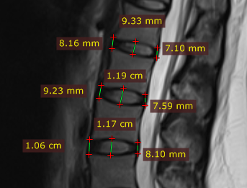
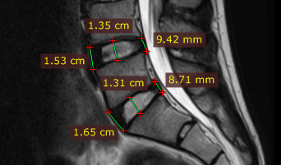
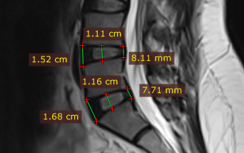
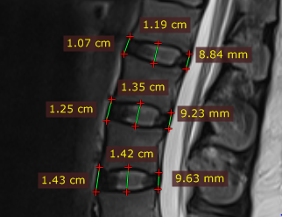
A
B
D
C

Fig (1):T2 weighted sagittal MRI image of (A) a 21-year-old female showing measurements of AIVH, MIVH & PIVH of L1,L2&L3 intervertebral discs (B) a 28-year-old male showing measurements of AIVH, MIVH &PIVH of L4&L5 intervertebral discs (C) a 38-year-old male showing measurements of AIVH, MIVH & PIVH of L1,L2&L3 intervertebral discs (D) a 36-year-old female showing measurements of AIVH, MIVH & PIVH of L4&L5 intervertebral discs.

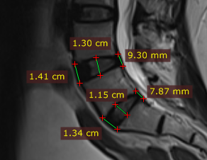
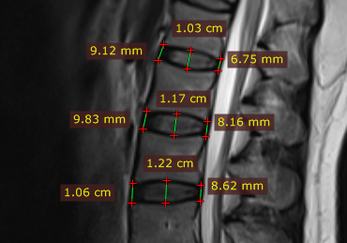
A
B

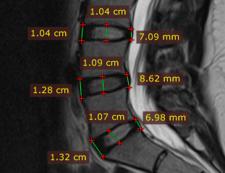
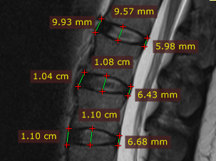
D
C

Fig (2): T2 weighted sagittal MRI image of (A) a 47-year-old male showing measurements of AIVH, MIVH & PIVH of L1,L2&L3 intervertebral discs (B) a 46-year-old female showing measurements of AIVH, MIVH & PIVH of L4&L5 intervertebral discs (C) a 54-year-old male showing measurements of AIVH, MIVH & PIVH of L1,L2&L3 intervertebral discs (D)a 56-year-old female showing measurements of AIVH, MIVH & PIVH of L4&L5 intervertebral discs.
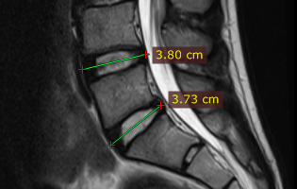
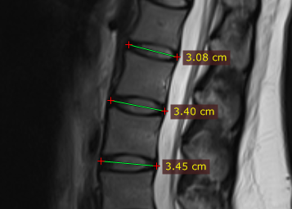
A
B

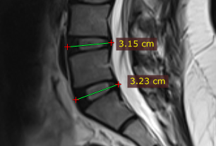
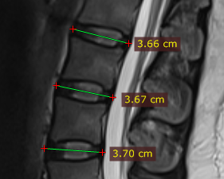
C
D

Fig (3): T2 weighted sagittal MRI image of (A) a 21-year-old female showing measurements of APDL of L1, L2 & L3 intervertebral discs, (B) a 28-year-old male showing measurements of APDL of L4, L5 intervertebral discs, (C) a 38-year-old male showing measurements of APDL of L1, L2 & L3 intervertebral discs, (D) a 36-year-old female showing measurements of APDL of L4, L5 intervertebral discs.
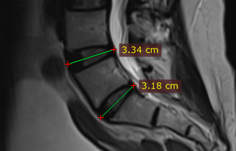
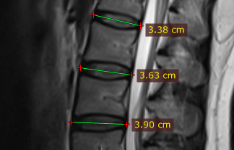
A
B

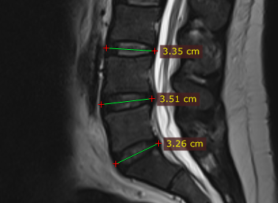
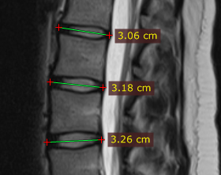
D
C

Fig (4): T2 weighted sagittal MRI image of (A) a 47-year-old male showing measurements of APDL of L1, L2 & L3 intervertebral discs, (B) a 46-year-old female showing measurements of APDL of L4, L5 intervertebral discs, (C) a 53-year-old female showing measurements of APDL of L1, L2, L3 intervertebral discs, (D) a 55-year-old male showing measurements of APDL of L3, L4 & L5 intervertebral discs
A
B
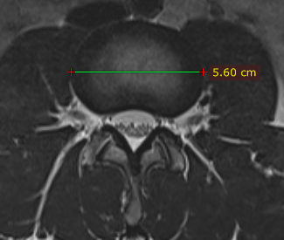
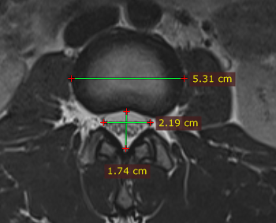

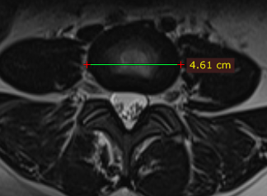
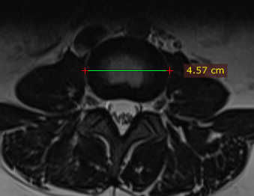
C
D

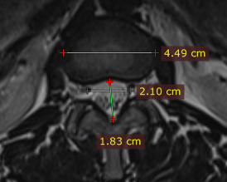
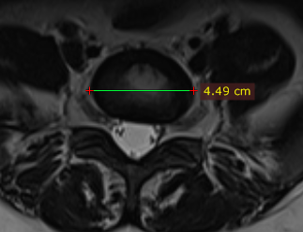
E
F

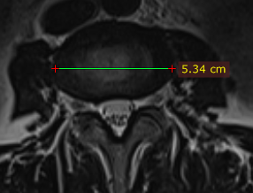
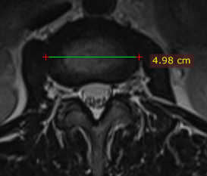
G
H

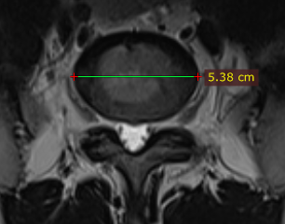
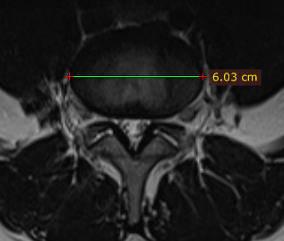
I
J

Fig (5): T2-weighted AXIAL MRI image of a 24-year-old male showing measurements of (A) TD of L1 intervertebral disc& spinal canal AP diameter and spinal canal width at L1 disc (B) TD of L2 disc, a 26-year-old female showing measurements of (C) TD of L3 disc (D) TD of L4 disc (E) TD of L5 disc, , a 38-year-old female showing measurements of (F) TD of L1& spinal canal AP diameter and spinal canal width at L1 disc (G) TD of L2 disc (H) TD of L3 disc , a 33-year-old male showing measurements of (I) TD of L4 disc (J) TD of L5 disc

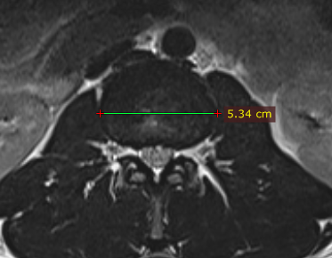
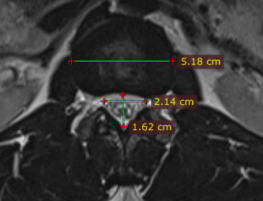
B
A

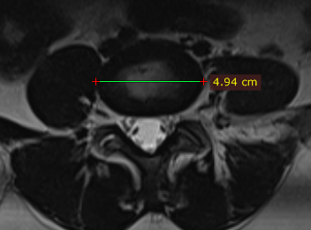
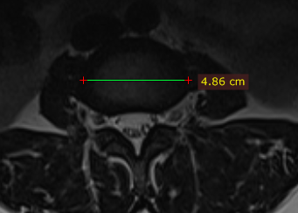
C
D

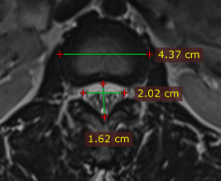
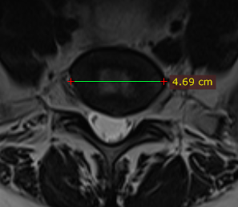
F
E

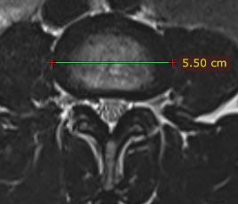
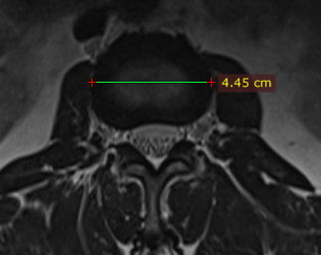
G
H

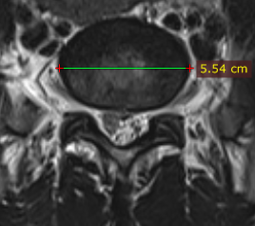
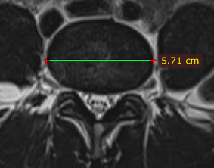
I
J

Fig (6): T2-weighted AXIAL MRI image of a 42-year-old male showing measurements of (A) TD of L1& spinal canal AP diameter and spinal canal width at L1 disc (B) TD of L2 disc, a 41-year-old female showing measurements of (C) TD of L3 disc (D) TD of L4 disc (E) TD of L5 disc, , a 51-year-old female showing measurements of (F) TD of L1& spinal canal AP diameter and spinal canal width at L1 disc (G) TD of L2 disc. a 58-year-old male showing measurements of (H) TD of L3 disc (I) TD of L4 disc (J) TD of L5 disc.

